**UNCOVERING THE GAMING INDUSTRY’S**

**HIDDEN GEMS: A COMPREHENSIVE**

**ANALYSIS OF VIDEO GAME SALES**

1. **INTRODUCTION**
   1. **Overview**

Video game sales analysis may be conducted by game developers, publishers, retailers, and other industry professionals. It is an important part of the video game industry, as it helps to understand the needs and preferences of consumers and to identify opportunities for growth and innovations. The data set we analysed consists of many platform and companies publishing various video games. Among them many companies with same genre are at the top ranking and many are at bottom. Hence we have planned to get the insights of rankings through our dataset. Video games sales analysis typically involves collecting data from Kaggle sources. It was generated by a scrape of vgchartz.com. This data may include information about the number of units sold, the retail price, and the platforms on which the games are played. Once the data has been collected, it is typically analysed using tableau. The result of the analysis can be used to identify trends and patterns in the market, and to make informed decisions about the development and marketing of video games. The data set we collected has 16,500 games. We filtered our data using MySQL workbench and selected first 100 rows in the dataset for our study.

* 1. **Purpose**

The main purpose was to analyse the sales of video games in different regions. The regions are North America, Europe, Japan, other countries and then the global sales (total of all the regions). The main idea was to visualize the sales for different genres, publishers and platforms. Analysing video game sales would give the basic idea about the most popular genres, publishers and platforms amongst all. And also it would give what are the insights that we have to give to the lowest rank video games.

1. **PROBLEM DEFINITION AND DESIGN THINKING**
   1. **Empathy Map**

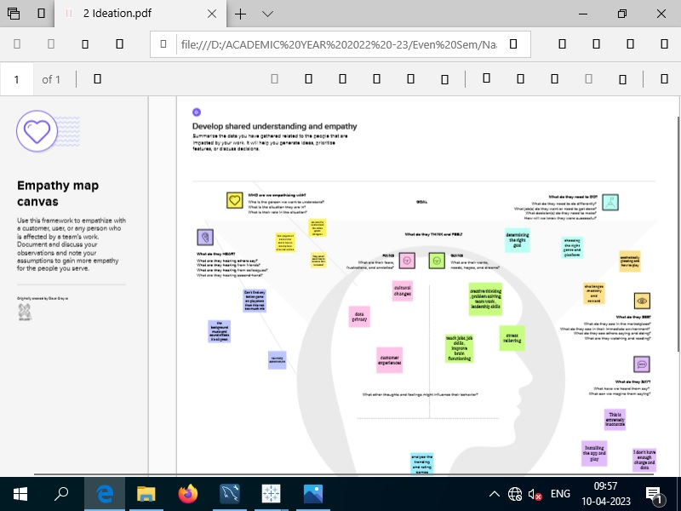

* 1. **Ideation and Brainstorming Map**

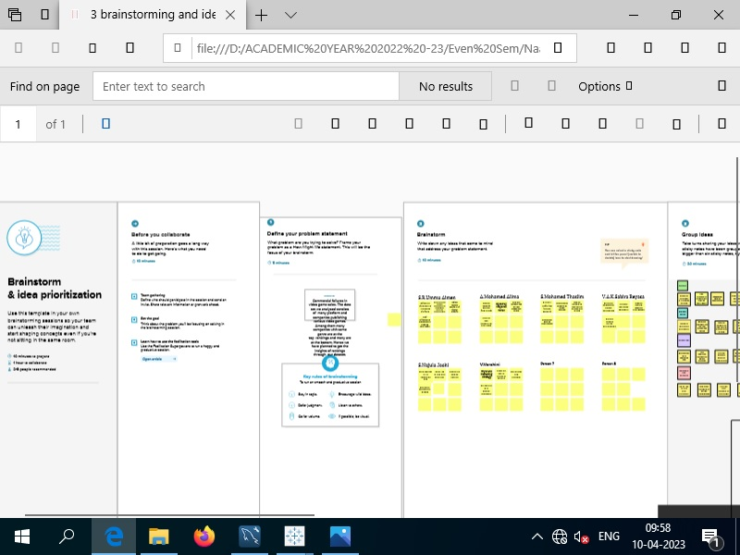

1. **RESULT**

**Dashboards 1 and 2**

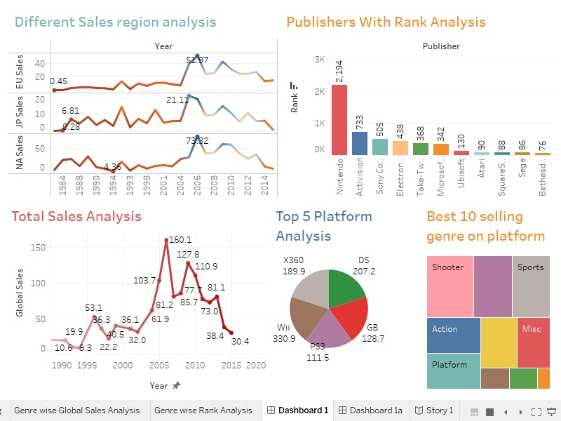

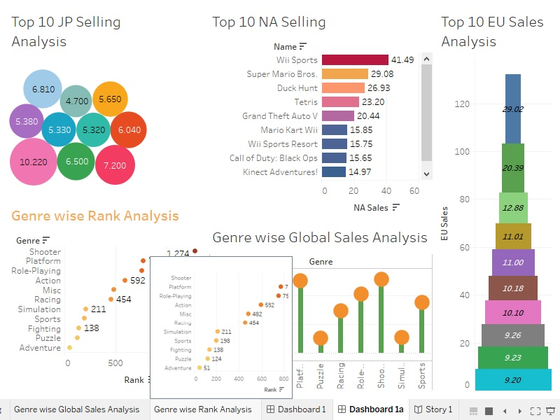**Story**

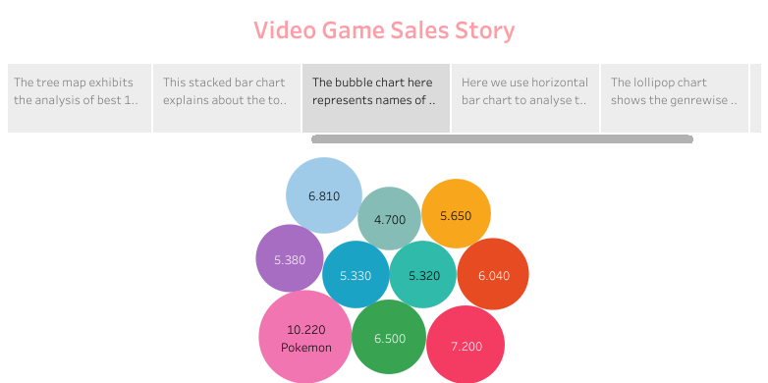

**Web Application**

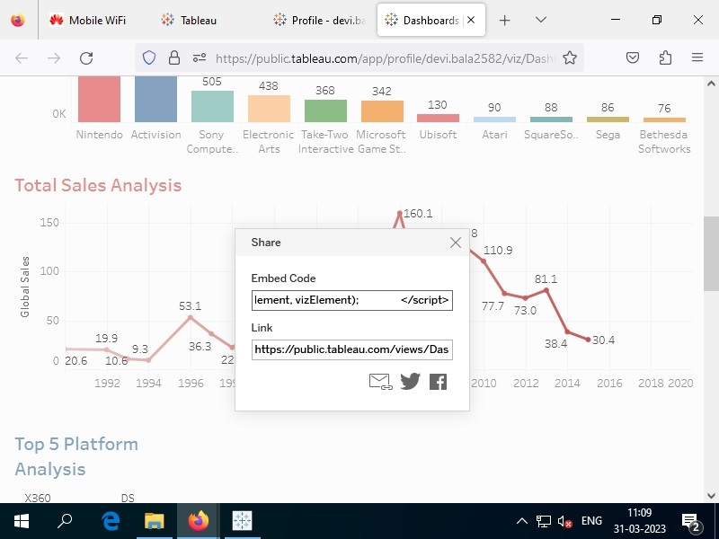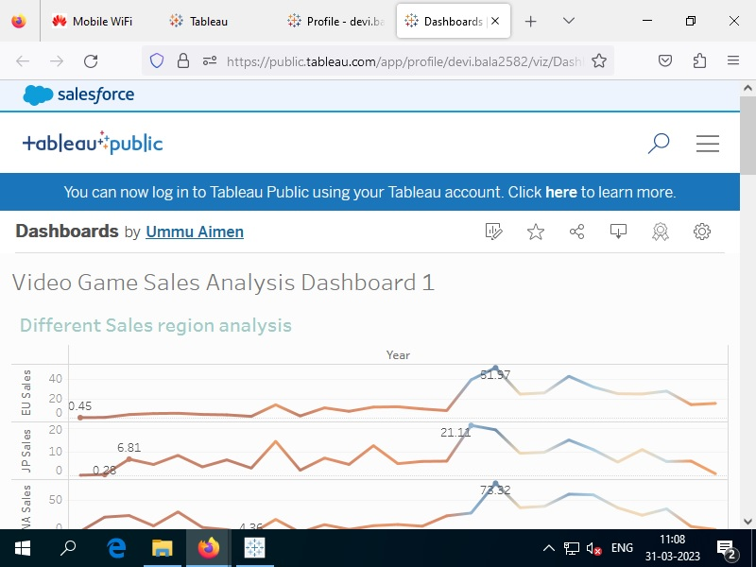

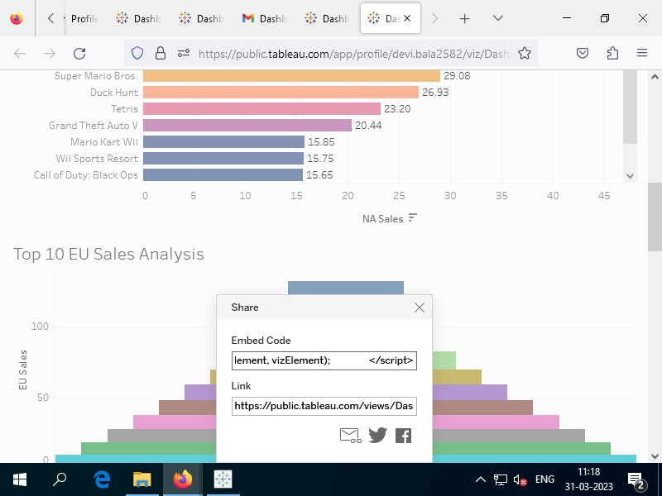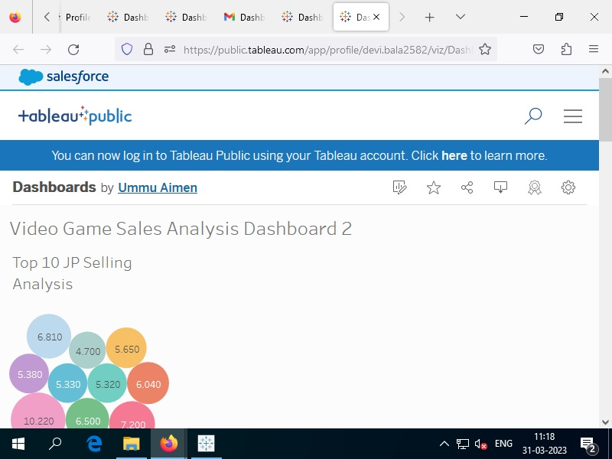

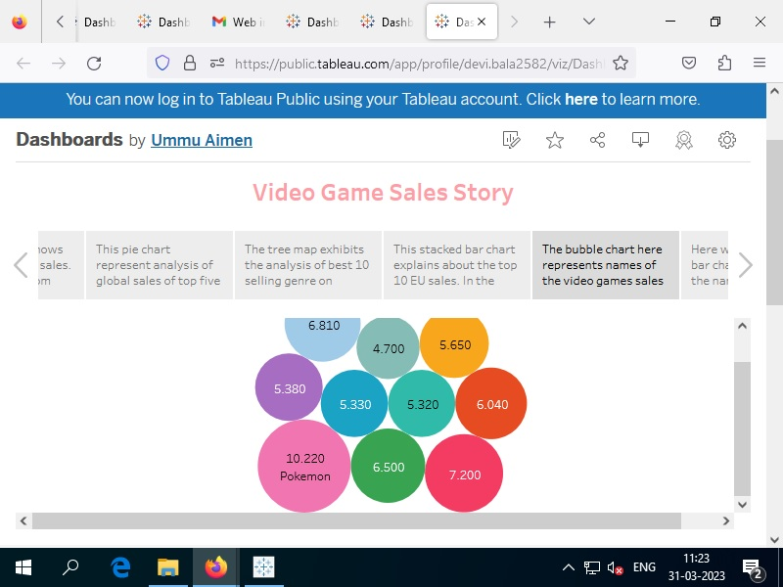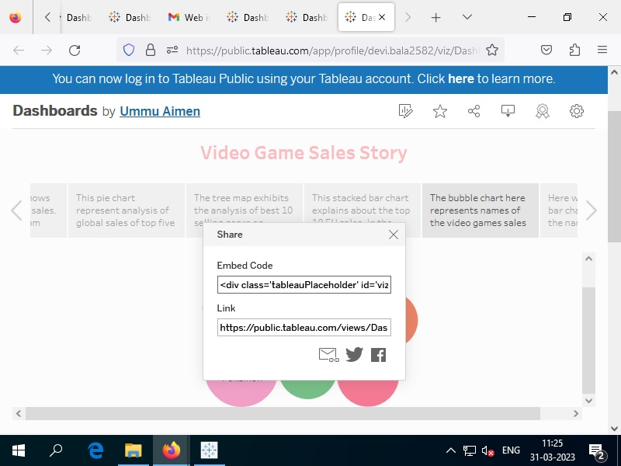

1. **ADVANTAGES AND DISADVANTAGES**

**Advantages**

* Marketing that is properly researched and targeted will bring new and returning customers.
* The more we analyse the games we play, the more we understand what makes a game good.
* Free advertisement.
* Assures better quality performance in every sphere of activity.
* Low potential is ideal as this means a smoother game play is experienced.
* Strategy games encourage players to make plans, manage resources and balance competing objectives.
* They stimulate creativity, focus and visual memory**.**

**Disadvantages**

Marketing can be expensive and drain profits, especially for smaller business.

* Reviews can be inaccurate or false.
* Quality is expensive.
* Low latency network generally experience small delays.
* Reviews or scores can affect a game's success in terms of revenue
* There is limited literature that addresses the topic from a business marketing perspective.

1. **APPLICATIONS**

Using this video game sales analysis, we can explore the top region in sales. It is also used to discover the best genre of video games. It enhances research activities to locate available positions within the videogame industry. Reviews establish business as a force in the industry. Reviews increase website traffic and generate leads. Insights given to a developer sets out business goals, including who your ideal customers are and how you intend to reach them. As far as software is concerned, we can create our own games.

1. **CONCLUSION**

The videogame data set downloaded from Kaggle source and has been analysed in this project. We filtered first 100 ranks from the original dataset for our analysis. The graphical representations and visualization are prepared to explore the data to identify patterns, trends and get useful insights.

* + In year wise different sales regions we understand that in 2006 both European Sales (EU) and North Africa (NA) sales reached the maximum value of 51.97 million and 73.82 million respectively. In 2005 Japan (JP) sales reached the maximum value of 21.11 million. North Africa places the top sales compared to other two regions.
  + In the analysis of publishers in top 10 ranks we found that the topmost publisher is Nintendo and have 2194 ranks. The last place was taken by Bethesda soft works which has 76 ranks. Nintendo, Activision and Sony Computer Entertainment acquire the first three places.
  + In the year wise global sales from 1990 to 2020 we explore that, in the year 2006 video game sales reached the maximum value of 160.1 million globally. In the year 1994, there was major drop in the sales of 9.3 million.
  + The analysis of global sales of top five platforms shows that Wii platform with 330.9 million sales holds the first place. PS3 holds the fifth place with 111.5 million sales.
  + The analysis of best 10 selling genre on platform gives us the data that Shooter genre is in the first place with sales of 220.8 million. Fighting genre is in the tenth place with 20.5 million.
  + The top 10 EU sales analysis tells us that in the European region, Wii sports video game holds the top sales with 29.02 million. Wii play video game holds the last place with 9.20 million sales.
  + The analysis of top 10 video games sales in Japan states that The Pokemon Red/ Pokemon Blue holds the first place in sales with 10.220 million. The New Super Mario Bros.Wii video games had a sales drop with 4.700 million which takes the last place in Japanese video game sales.
  + The analysis of top 10 video games sales in North America infers that, in the first place Wii sports is there with highest sales of 41.49 million and New Super Mario Bros.Wii is at the last place with sales of 14.59 millions
  + The genre wise global sales analysis gives the information that platform genre and shooter genre acquires top sales 251.9 and 257.6 million respectively. Adventure and Fighting genre has least sales with 11.2 and 20.5 million.
  + The analysis of genre wise rank analysis shows that Shooter acquires top rank with 1274 ranks and Adventure holds the last place with 51 ranks.

So we conclude that from these analyses, the publisher Nintendo of Japan conquers the world of video games. The publishers prefer the Wii platform mostly for publishing their games. The best genre the customers prefer was found to be shooter. The total sales strongly peaked during the year 2006 with 160.1 million sales, and after that, it gradually decreased and reached 30.4 million in the year 2015. In region wise sales analysis, North America holds the top sales in 2006. In the European region, the Wii sports platform holds the top sales. In the Japan region, Pokemon Red/ Pokemon Blue platforms hold the top sales. In the North America region, Wii sports hold the top sales. All the whole Wii Sports platform was most likely to be the best platform. This analysis helps to gain more customers increasing the sales. By using gaming podcast, lots of exciting news and updates are available and it helps to gain exposure to a group of gaming followers.

1. **FUTURE SCOPE**

The gaming company has become a data-centric company. They want to get the real-time data. Tableau comes into the picture here which makes huge impact in data analytics. In this project we have analysed a set of data of video game sales using Tableau. We have created dashboards to give some insights. In future we will use more graphs, charts, histograms for our analysis. We will try to offer geographical insights using the geographical maps. We will try to explore more Tableau tools to give more interactive dashboards.

1. **APPENDIX**
2. **Source code**

**Dashboard 1 HTML code:**

|  |  |
| --- | --- |
| <!DOCTYPE html> | |
|  | | <html> | | |
|  | | <head> | | |
|  | | <meta charset="UTF-8"> | | |
|  | | <title>Video Game Sales Analysis Dashboard</title> | | |
|  | | <style> | | |
|  | | body { | | |
|  | | font-family: Arial, sans-serif; | | |
|  | | margin: 0; | | |
|  | | padding: 0; | | |
|  | | } | | |
|  | |  | | |
|  | | /* Navigation menu styles */ | | |
|  | | nav { | | |
|  | | background-color: #333; | | |
|  | | color: white; | | |
|  | | overflow: hidden; | | |
|  | | } | | |
|  | |  | | |
|  | | nav a { | | |
|  | | float: left; | | |
|  | | color: white; | | |
|  | | text-align: center; | | |
|  | | padding: 14px 16px; | | |
|  | | text-decoration: none; | | |
|  | | } | | |
|  | |  | | |
|  | | nav a:hover { | | |
|  | | background-color: #ddd; | | |
|  | | color: black; | | |
|  | | } | | |
|  | |  | | |
|  | | /* Content styles */ | | |
|  | | #content { | | |
|  | | padding: 20px; | | |
|  | | } | | |
|  | |  | | |
|  | | h1 { | | |
|  | | margin-top: 0; | | |
|  | | } | | |
|  | |  | | |
|  | | /* Embedded dashboard styles */ | | |
|  | | .tableauPlaceholder { | | |
|  | | margin-top: 20px; | | |
|  | | } | | |
|  | | </style> | | |
|  | | </head> | | |
|  | | <body> | | |
|  | | <nav> | | |
|  | | <a href="#sales">Sales</a> | | |
|  | | <a href="#platforms">Platforms</a> | | |
|  | | <a href="#genres">Genres</a> | | |
|  | | <a href="#publishers">Publishers</a> | | |
|  | | </nav> | | |
|  | |  | | |
|  | | <div id="content"> | | |
|  | | <h1>Video Game Sales Analysis Dashboard</h1> | | |
|  | |  | | |
|  | | <div class='tableauPlaceholder' id='viz1681361648439' style='position: relative'><noscript><a href='#'><img alt='Video Game Sales Analysis Dashboard 1 ' src='https:&#47;&#47;public.tableau.com&#47;static&#47;images&#47;Da&#47;Dashboards_16802402180640&#47;Dashboard1&#47;1_rss.png' style='border: none' /></a></noscript><object class='tableauViz' style='display:none;'><param name='host_url' value='https%3A%2F%2Fpublic.tableau.com%2F' /> <param name='embed_code_version' value='3' /> <param name='site_root' value='' /><param name='name' value='Dashboards_16802402180640&#47;Dashboard1' /><param name='tabs' value='no' /><param name='toolbar' value='yes' /><param name='static_image' value='https:&#47;&#47;public.tableau.com&#47;static&#47;images&#47;Da&#47;Dashboards_16802402180640&#47;Dashboard1&#47;1.png' /> <param name='animate_transition' value='yes' /><param name='display_static_image' value='yes' /><param name='display_spinner' value='yes' /><param name='display_overlay' value='yes' /><param name='display_count' value='yes' /><param name='language' value='en-US' /></object></div> <script type='text/javascript'> var divElement = document.getElementById('viz1681361648439'); var vizElement = divElement.getElementsByTagName('object')[0]; if ( divElement.offsetWidth > 800 ) { vizElement.style.width='100%';vizElement.style.height=(divElement.offsetWidth*0.75)+'px';} else if ( divElement.offsetWidth > 500 ) { vizElement.style.width='100%';vizElement.style.height=(divElement.offsetWidth*0.75)+'px';} else { vizElement.style.width='100%';vizElement.style.height='1577px';} var scriptElement = document.createElement('script'); scriptElement.src = 'https://public.tableau.com/javascripts/api/viz_v1.js'; vizElement.parentNode.insertBefore(scriptElement, vizElement); </script> | | |
|  | | </div> | | |
|  | |  | | |
|  | | <script type='text/javascript'> | | |
|  | | var divElement = document.getElementById('viz1681361648439'); | | |
|  | | var vizElement = divElement.getElementsByTagName('object')[0]; | | |
|  | | if (divElement.offsetWidth > 800) { | | |
|  | | vizElement.style.width = '100%'; | | |
|  | | vizElement.style.height = (divElement.offsetWidth * 0.  Dashboard 2 HTML code   |  | | --- | | <!DOCTYPE html> | |  | <html> | |  | <head> | |  | <meta charset="UTF-8"> | |  | <title>Video Game Sales Analysis Dashboard 2</title> | |  | <style> | |  | body { | |  | font-family: Arial, sans-serif; | |  | margin: 0; | |  | padding: 0; | |  | } | |  |  | |  | /* Navigation menu styles */ | |  | nav { | |  | background-color: #333; | |  | color: white; | |  | overflow: hidden; | |  | } | |  |  | |  | nav a { | |  | float: left; | |  | color: white; | |  | text-align: center; | |  | padding: 14px 16px; | |  | text-decoration: none; | |  | } | |  |  | |  | nav a:hover { | |  | background-color: #ddd; | |  | color: black; | |  | } | |  |  | |  | /* Content styles */ | |  | #content { | |  | padding: 20px; | |  | } | |  |  | |  | h1 { | |  | margin-top: 0; | |  | } | |  |  | |  | /* Embedded dashboard styles */ | |  | .tableauPlaceholder { | |  | margin-top: 20px; | |  | } | |  | </style> | |  | </head> | |  | <body> | |  | <nav> | |  | <a href="#sales">Sales</a> | |  | <a href="#platforms">Platforms</a> | |  | <a href="#genres">Genres</a> | |  | <a href="#publishers">Publishers</a> | |  | </nav> | |  |  | |  | <div id="content"> | |  | <h1>Video Game Sales Analysis Dashboard 2</h1> | |  |  | |  | <div class='tableauPlaceholder' id='viz1681363100658' style='position: relative'><noscript><a href='#'><img alt='Video Game Sales Analysis Dashboard 2 ' src='https:&#47;&#47;public.tableau.com&#47;static&#47;images&#47;Da&#47;Dashboards_16802402180640&#47;Dashboard1a&#47;1_rss.png' style='border: none' /></a></noscript><object class='tableauViz' style='display:none;'><param name='host_url' value='https%3A%2F%2Fpublic.tableau.com%2F' /> <param name='embed_code_version' value='3' /> <param name='site_root' value='' /><param name='name' value='Dashboards_16802402180640&#47;Dashboard1a' /><param name='tabs' value='no' /><param name='toolbar' value='yes' /><param name='static_image' value='https:&#47;&#47;public.tableau.com&#47;static&#47;images&#47;Da&#47;Dashboards_16802402180640&#47;Dashboard1a&#47;1.png' /> <param name='animate_transition' value='yes' /><param name='display_static_image' value='yes' /><param name='display_spinner' value='yes' /><param name='display_overlay' value='yes' /><param name='display_count' value='yes' /><param name='language' value='en-US' /></object></div> <script type='text/javascript'> var divElement = document.getElementById('viz1681363100658'); var vizElement = divElement.getElementsByTagName('object')[0]; if ( divElement.offsetWidth > 800 ) { vizElement.style.width='100%';vizElement.style.height=(divElement.offsetWidth*0.75)+'px';} else if ( divElement.offsetWidth > 500 ) { vizElement.style.width='100%';vizElement.style.height=(divElement.offsetWidth*0.75)+'px';} else { vizElement.style.width='100%';vizElement.style.height='1577px';} var scriptElement = document.createElement('script'); scriptElement.src = 'https://public.tableau.com/javascripts/api/viz_v1.js'; vizElement.parentNode.insertBefore(scriptElement, vizElement); </script> | |  | </div> | |  |  | |  | <script type='text/javascript'> | |  | var divElement = document.getElementById('viz1681361648439'); | |  | var vizElement = divElement.getElementsByTagName('object')[0]; | |  | if (divElement.offsetWidth > 800) { | |  | vizElement.style.width = '100%'; | |  | vizElement.style.height = (divElement.offsetWidth * 0. |   Story HTML code: | | |
| <!DOCTYPE html> | |
|  | | <html> |
|  | | <head> |
|  | | <meta charset="UTF-8"> |
|  | | <title>Story Dashboard</title> |
|  | | <style> |
|  | | /* Style the header */ |
|  | | header { |
|  | | background-color: #333; |
|  | | color: white; |
|  | | text-align: center; |
|  | | padding: 20px; |
|  | | } |
|  | |  |
|  | | /* Style the navigation bar */ |
|  | | nav { |
|  | | background-color: #f2f2f2; |
|  | | overflow: hidden; |
|  | | } |
|  | |  |
|  | | nav a { |
|  | | float: left; |
|  | | display: block; |
|  | | color: black; |
|  | | text-align: center; |
|  | | padding: 14px 16px; |
|  | | text-decoration: none; |
|  | | } |
|  | |  |
|  | | nav a:hover { |
|  | | background-color: #ddd; |
|  | | color: black; |
|  | | } |
|  | |  |
|  | | /* Style the content */ |
|  | | .content { |
|  | | padding: 20px; |
|  | | } |
|  | |  |
|  | | /* Style the footer */ |
|  | | footer { |
|  | | background-color: #333; |
|  | | color: white; |
|  | | text-align: center; |
|  | | padding: 20px; |
|  | | position: absolute; |
|  | | bottom: 0; |
|  | | width: 100%; |
|  | | } |
|  | | </style> |
|  | | </head> |
|  | | <body> |
|  | | <header> |
|  | | <h1>Story Dashboard</h1> |
|  | | </header> |
|  | |  |
|  | | <nav> |
|  | | <a href="#introduction">Introduction</a> |
|  | | <a href="#data">Data</a> |
|  | | <a href="#analysis">Analysis</a> |
|  | | <a href="#conclusion">Conclusion</a> |
|  | | </nav> |
|  | |  |
|  | | <div class="content"> |
|  | | <h2 id="introduction">Introduction</h2> |
|  | | <p>Here you can introduce your story and provide some background information.</p> |
|  | |  |
|  | | <h2 id="data">Data</h2> |
|  | | <p>Describe the data you have collected for your analysis.</p> |
|  | |  |
|  | | <h2 id="analysis">Analysis</h2> |
|  | | <p>Present your findings and analysis using charts, graphs, and other visualizations. Embed your dashboard here:</p> |
|  | | <div class='tableauPlaceholder' id='viz1681364223190' style='position: relative'><noscript><a href='#'><img alt='Video Game Sales Story ' src='https:&#47;&#47;public.tableau.com&#47;static&#47;images&#47;Da&#47;Dashboards_16802402180640&#47;Story1&#47;1_rss.png' style='border: none' /></a></noscript><object class='tableauViz' style='display:none;'><param name='host_url' value='https%3A%2F%2Fpublic.tableau.com%2F' /> <param name='embed_code_version' value='3' /> <param name='site_root' value='' /><param name='name' value='Dashboards_16802402180640&#47;Story1' /><param name='tabs' value='no' /><param name='toolbar' value='yes' /><param name='static_image' value='https:&#47;&#47;public.tableau.com&#47;static&#47;images&#47;Da&#47;Dashboards_16802402180640&#47;Story1&#47;1.png' /> <param name='animate_transition' value='yes' /><param name='display_static_image' value='yes' /><param name='display_spinner' value='yes' /><param name='display_overlay' value='yes' /><param name='display_count' value='yes' /><param name='language' value='en-US' /></object></div> <script type='text/javascript'> var divElement = document.getElementById('viz1681364223190'); var vizElement = divElement.getElementsByTagName('object')[0]; vizElement.style.width='100%';vizElement.style.height=(divElement.offsetWidth*0.75)+'px'; var scriptElement = document.createElement('script'); scriptElement.src = 'https://public.tableau.com/javascripts/api/viz_v1.js'; vizElement.parentNode.insertBefore(scriptElement, vizElement); </script> |
|  | |  |
|  | | <h2 id="conclusion">Conclusion</h2> |
|  | | <p>Wrap up your story and provide some key takeaways and recommendations.</p> |
|  | | </div> |
|  | |  |
|  | | <footer> |
|  | | <p>&copy; 2023 Story Dashboard. All rights reserved.</p> |
|  | | </footer> |
|  | |  |
|  | | </body> |
|  | | </html> |